Protein Fold Recognition by Prediction-based Threading
Burkhard Rost, Reinhard Schneider and Chris Sander, Molecular Biology, Vol. 270, pp. 471-480, 1997
Abstract
The quality of sequence-structure fit is typically evaluated using inter-residue potentials of mean force or other statistical parameters. Here we present an alternative approach to evaluating sequence-structure fitness. Starting from the amino acid sequence we first predict secondary structure and solvent accessibility for each residue. We then thread the resulting one-dimensional profile of predicted structure assignment into each of the known 3D structures. The method is fine-tuned by adding information from direct sequence-sequence comparison and applying a series of empirical filters. Although the method relies on reduction of 3D information into 1D structure profiles, its accuracy is, surprisingly, not clearly inferior to methods based on evaluation of residue interactions in 3D.
- Methods
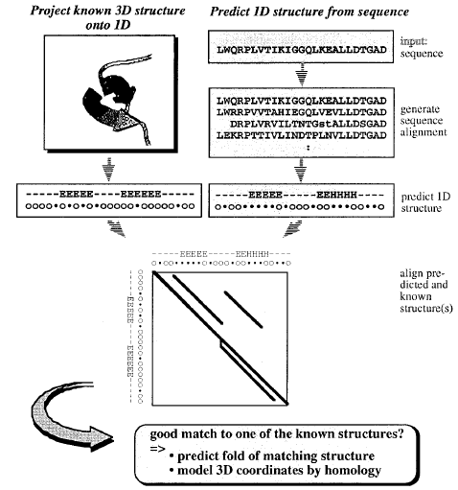
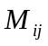 = 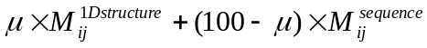

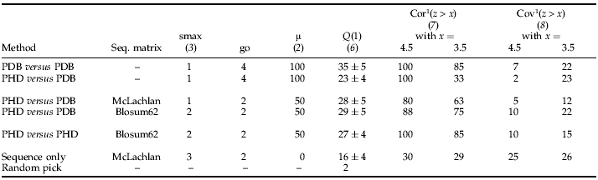
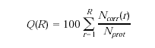
where 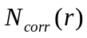give the number of correct first–rank folds at rank r and 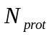 is the number of probe sequences in the test set.

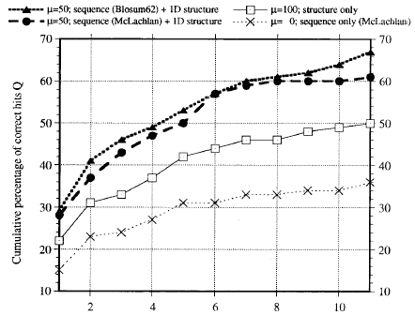

Created by: Chia-Chang Wang
Date: May 28,2004

